LFA Terms of References: Supply Chain Information Systems Data Quality Review

July 2025

Background:
Supply chain information systems including Logistics Management Information Systems (LMIS) and warehouse management systems (WMS) are critical enablers for data flows and decision making of the supply chain. The Global Fund is supporting the establishment and strengthening of various supply chain information systems. As such, it is critical to ensure the data quality of these systems.

Objective(s):
The objective of this exercise is to assess:
- Quantitative assessment - extent to which the data in the supply chain information systems matches the data in source documents
- Qualitative assessment of governance, processes & policies

Scope of Review:

- Quantitative assessment: Central medical store, sampled list of health facilities and supply chain headquarters/ disease program head offices (the sampling methodology is outlined in below section)
- Qualitative assessment - Central Medical Store (CMS), two regional warehouses (WH), sampled list of health facilities and supply chain headquarters (HQ)/disease program head offices
- Tracer product list – select HIV/TB/Malaria tracer products would be used for this assessment. The Global Fund will share the list of tracers with the LFA.

Tasks:

The LFA is expected to assess and verify the data quality using the Supply Chain Information System Data Quality Review Tool (excel). The tool consists of two elements as summarised below. More details are available in the readme sheet of the tool and in subsequent tabs of the file.

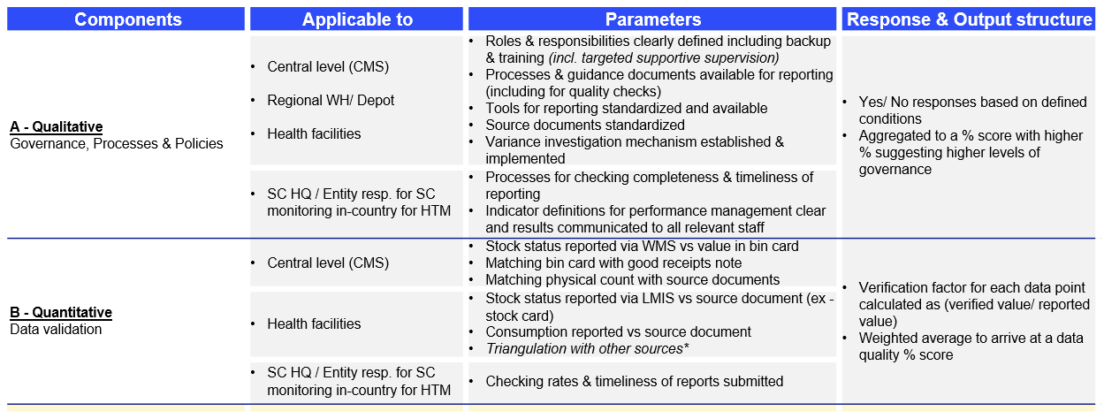

Output/Deliverables and timing of deliverables:

The LFA is expected to conduct the review and submit, as per the Country Team’s request, the completed review template (excel). The “Executive Summary” tab in the template should include without limitation:

- A detailed description of issues/variances identified, including the magnitude of their impact. The LFA should also comment on the context and possible root causes of the issues identified, providing background information, as necessary.
- Recommendations for addressing the identified key issues should be:
- Precise, detailed and actionable
- Few and prioritised
- Specific and contextualised
- Time-bound
- Identifying the main entity responsible for implementation

Service Delivery:
This task should be undertaken by the LFA PSM Expert who is accountable for the technical content of this report. S/he can be supported, as needed, by other LFA team members in the planning and during the verification. The LoE for this task, including completion of the template, depends on which elements of the ToR and the number and sites are included in the review, as agreed between the Global Fund Country Team and the LFA

Sampling methodology
It is recommended that at least 19 health facilities are randomly sampled from the list of facilities whose stock status and consumption data is available from eLMIS/ DHIS2. The final sample size should be defined by the CT based on the country size, context and risks.

Should the review identify clear evidence of fraud, the LFA should ensure it uses the GF communication protocol to inform the GF Secretariat and the OIG to allow consideration of evidence collection and other issues relevant to a possible criminal investigation.

